Japanese Font Generator

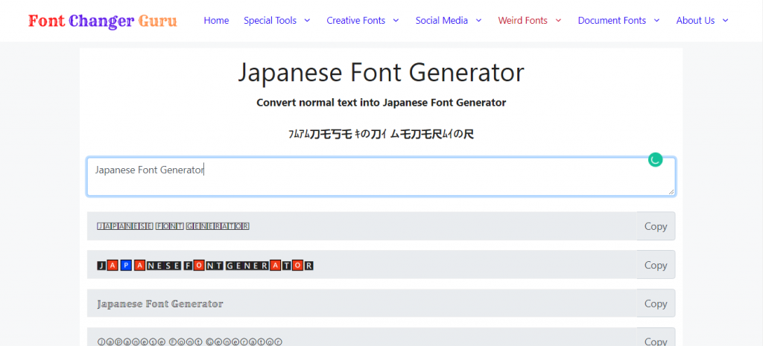

The [Japanese font generator](https://fontchangerguru.com/japanese-font-generator/) is one of the best Japanese font converter tools. Which converts your simple font text into cool Japanese text within a few moments. Copy and paste the best variation.

You have many reasons to choose a Japanese font generator. One of the major things is that our font changer provides many variations of different font styles. You can pick the best one according to your need or taste. Every different creation uses its character styles to make it different from others so that you can enjoy a variety of rare font styles.